A Project Report On
Quiz game
Developed By

Jay varu
Msc(it) Semester -1
Project Guide

PROF. harsh joshi


Submitted To

Geetanjali Collage of Computer Science & Commerce (BBA), Rajkot.
Academic Year: 2025-2026

Acknowledgement

I Am Happy To Submit My Idea Of "quiz game “Application In Saurashtra University, Rajkot For mscit Degree In Computer Branch.

I Also Grateful To Prof. Brijesh Shah Head of The Department And All The Faculty Members Of The Department Of Computer Science For Their Kind Support Through Out This Journey.

I Take The Privilege To Acknowledge The Elite Authors Of Numerous Books And Papers And Blogs Which We Have Referred During Progress Of This.

I Also Say The Big Thank You To My Parents For Such A Support And Without Them I Can Do Nothing Not In Just Project But Also In Life. Thankful To My Family For Their Support.

The Feeling Of Gratefulness To Any One's Help Directly Arises From The Bottom Of Heart. A Small But An Important And Timely Help Can Prove To Be A Milestone In One's Life.

Very Thankful To Almighty Of All Of "God" To Give Me Such A Best Persons And All The Thing He Provides Before I Need And I Always Feel That Without Him I Are Nothing.

Index

Sr. No | Title | Page No
1 | Project Profile | 1
2 | Software Development Life Cycle | 2
3 | System Requirement (For Development) | 5
4 | About the Tool (Tools & Technology used) | 6
5 | Use Case Diagram | 7
6 | DFD (Data Flow Diagram) | 8
7 | ER (Entity Relationship Diagram) | 9
8 | Data Dictionary | 10
9 | Screen Shots | 18
10 | Test Case | 47
11 | Limitation | 49
12 | Future Enhancement | 50
13 | Webliography | 51

Project Profile

Project Title | Quiz game
Development Software | VS Code
Frontend | HTML,CSS,JS,Bootstrap
Backend | laravel
Database | mysql
Academic Year | 2025 - 2026
Developed By | Jay varu
Submitted To | Geetanjali Group Of Colleges
Documentation Tool | Microsoft Word
Operating System | Windows
Language | php

Software Development Life Cycle

Waterfall Model:

The project follows the Waterfall Model for software development, where each phase is completed before the next begins, ensuring a sequential and systematic process.

Steps:

Requirement Gathering

Project Planning

Design

Coding & Implementation

Testing

Phases Explanation:

Requirement Gathering: Identified user needs and analysed similar quiz game websites.

Project Planning: Defined the project scope, technology stack, and task division.

Design: Created preliminary and final design mock-up’s for user interfaces.

Coding & Implementation: Developed the front-end and back-end systems based on the design and requirements.

Testing: Ensured the platform works as intended, including usability testing and bug fixing

System Requirement (For Development)

Hardware Requirements:

Processor: Intel Core i3 or equivalent (minimum)

RAM: 4 GB

Storage: 1 GB available space for development; more depending on the size of the database and media files.

Software Requirements:

Operating System: Windows/Linux/macOS

Database: MYSQL (for development)

IDE: Visual Studio Code

Programming Languages: HTML, CSS, JavaScript ,laravel

About the Tool (Tools & Technology Used)

Laravel: A PHP-based web application framework used for back-end development. It provides a robust MVC architecture, built-in authentication, routing, and security features for developing the quiz game efficiently.

HTML/CSS/JavaScript: Used for front-end development to create a responsive, interactive, and user-friendly quiz interface. JavaScript enhances real-time interactions such as question navigation and score calculation.

MySQL: A relational database management system used to store quiz questions, user details, scores, and game results securely and efficiently.

Visual Studio Code: An integrated development environment (IDE) used for writing, debugging, and managing the project source code.

Use Case Diagram

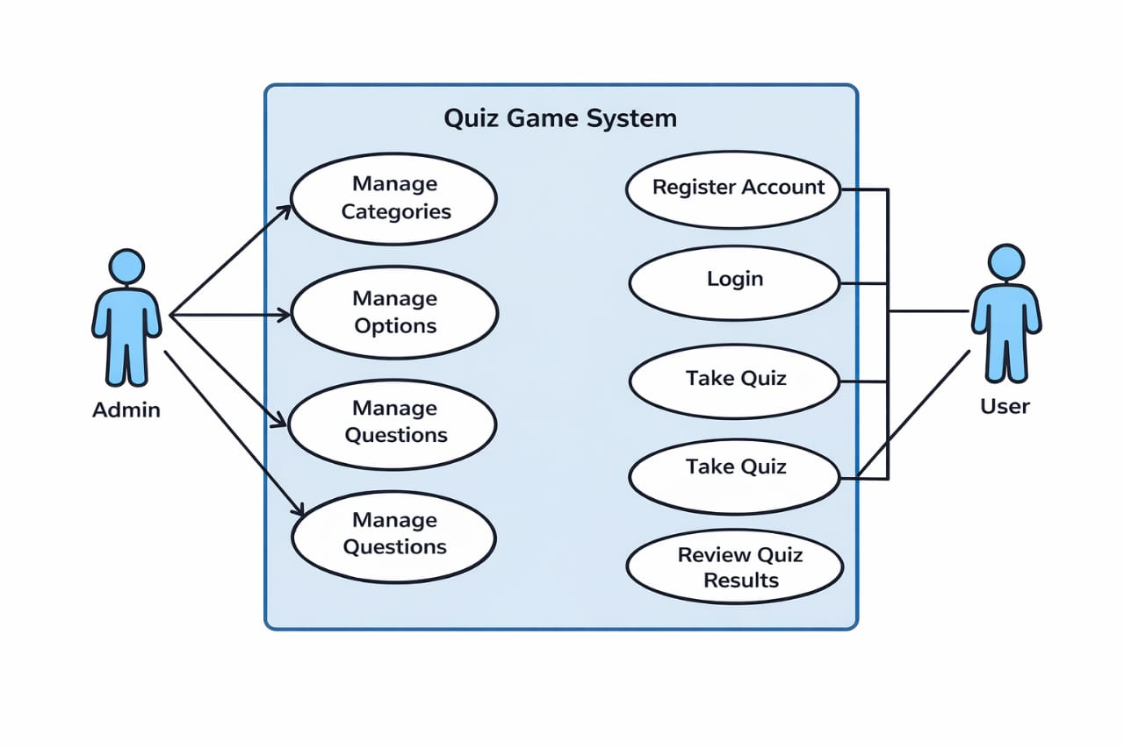

DFD (Data Flow Diagram)

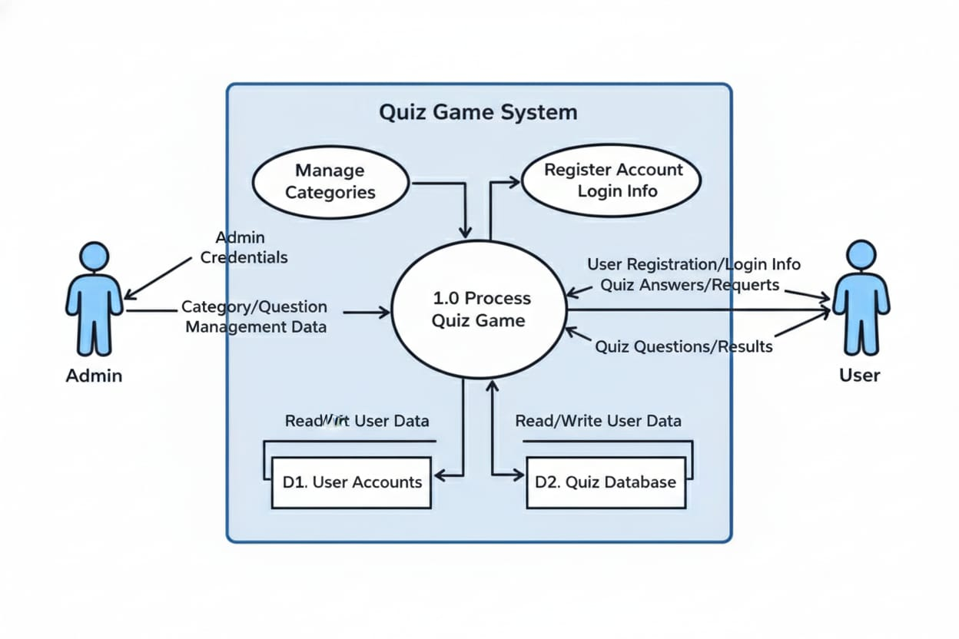

ER (Entity Relationship Diagram)

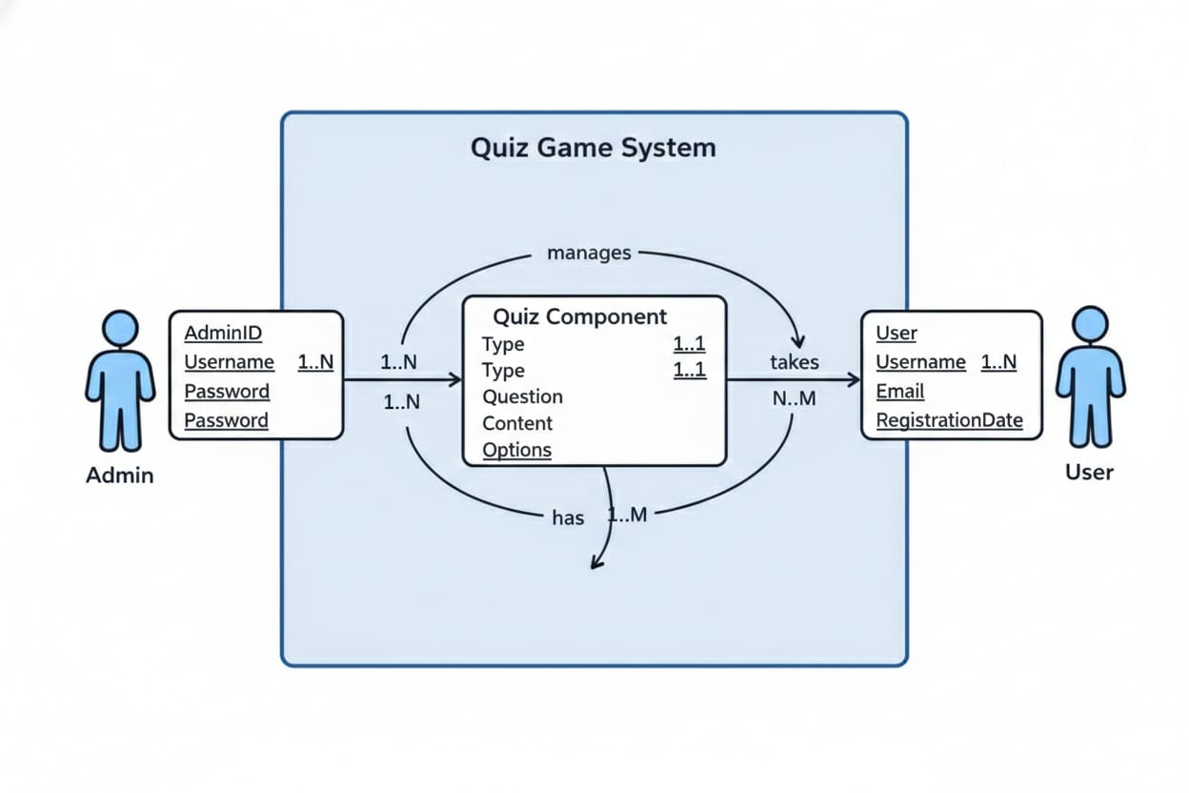

Data Dictionary

User Login:
Sr. No | Field Name | Data Type | Size
1 | Id | bigint | 20
2 | Name | varchar | 255
3 | Email | Email | -
4 | Email_verified_at | varchar | 255
5 | password | varchar | 255

Questions:

Sr No. | Field Name | Data Type | Size | Constraints
1 | id | BIGINT | 20 | Primary Key, Auto Increment, Unsigned, Not Null
2 | category_id | BIGINT | 20 | Foreign Key, Index, Unsigned, Not Null
3 | question | TEXT | — | Not Null
4 | points | INT | 11 | Not Null, Default 10
5 | time_limit | INT | 11 | Not Null, Default 30

Option table
Sr No. | Field Name | Data Type | Size | Constraints
1 | id | BIGINT | 20 | Primary Key, Auto Increment, Unsigned, Not Null
2 | question_id | BIGINT | 20 | Foreign Key, Index, Unsigned, Not Null
3 | option_text | VARCHAR | 255 | Not Null
4 | is_correct | TINYINT | 1 | Not Null, Default 0

Category table
Sr No. | Field Name | Data Type | Size | Constraints
1 | id | BIGINT | 20 | Primary Key, Auto Increment, Unsigned, Not Null
2 | name | VARCHAR | 255 | Not Null
3 | slug | VARCHAR | 255 | Not Null, Index
4 | description | TEXT | — | Nullable
5 | image | VARCHAR | 255 | Nullable
6 | is_active | TINYINT | 1 | Not Null, Default 1

Screen Shots
Dashboard

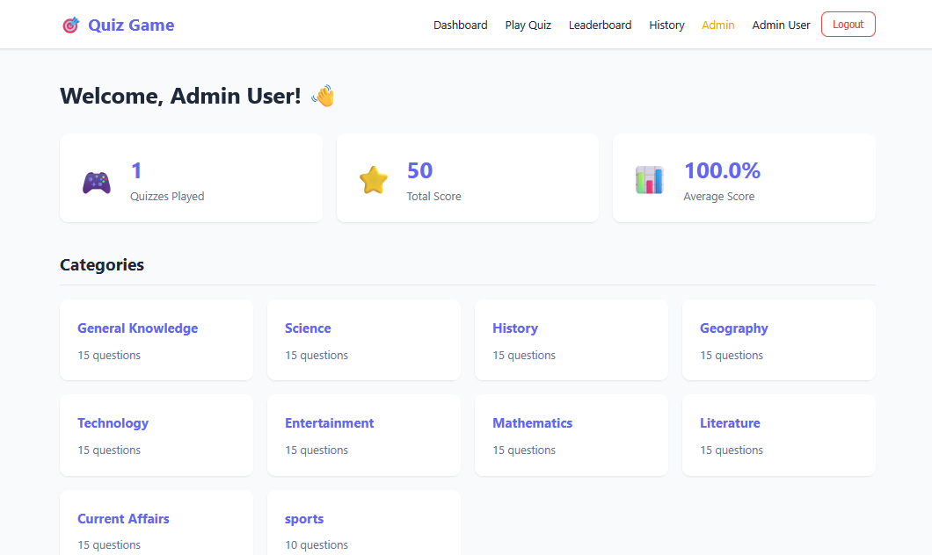

- This is the dashboard.
- User can show the all detail they can be showed here.

Categories

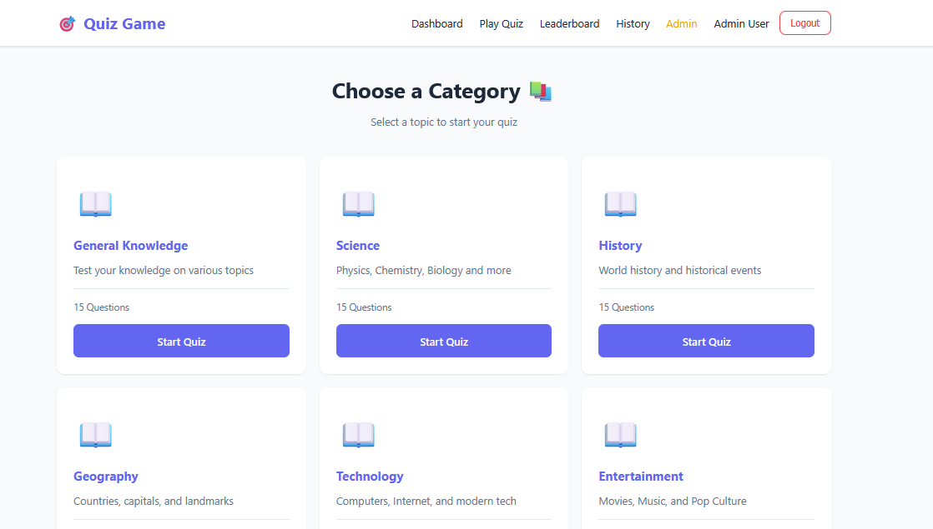

- This is the categories page user can show the all categories.
- User and admin also can show the all categories and also play a quiz.

Leaderboard

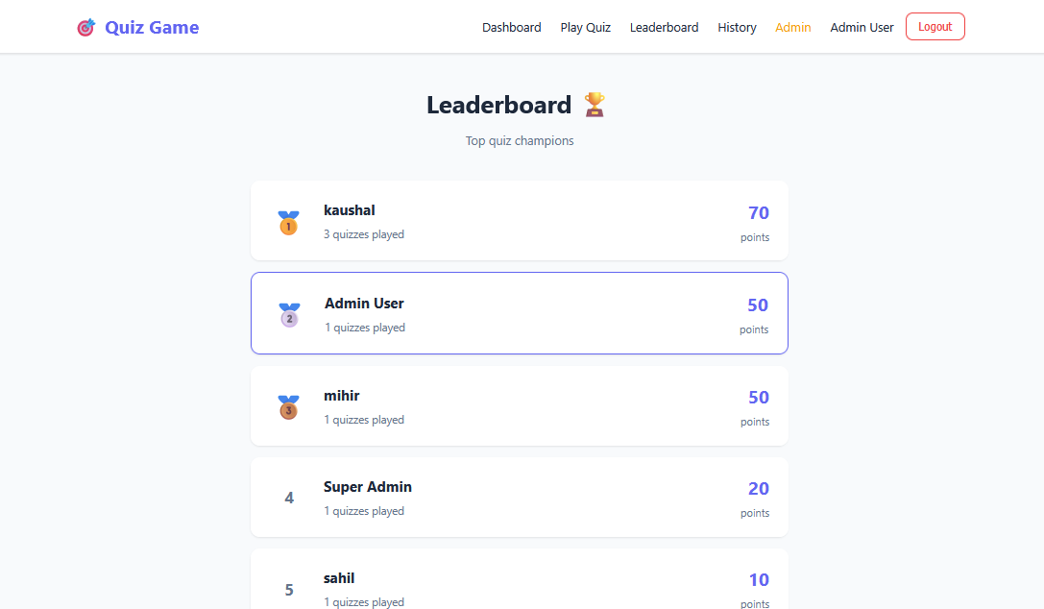

- Here is the leadderboard page.
- User can also the show the results the top categories.

history

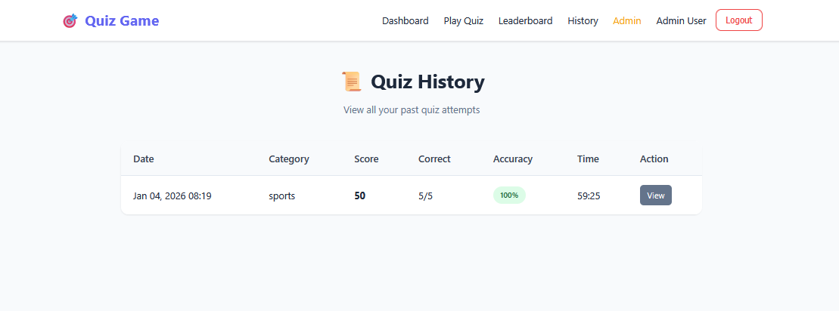

- this is the history page.
User and admin also see the history when they are play.
Login & register page
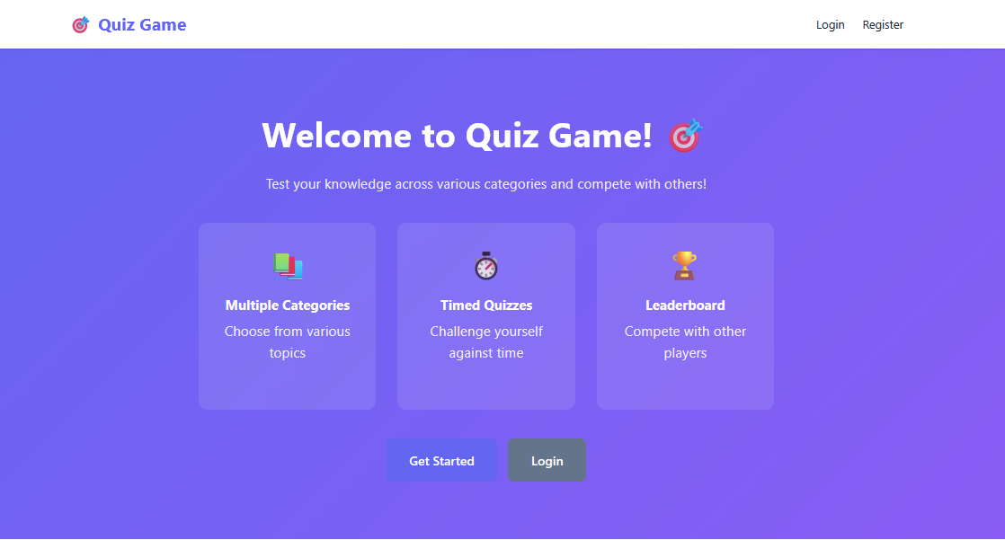

- Here is the login and registration page.
- New user also can register and privious user also login and enter to this page.

Result page

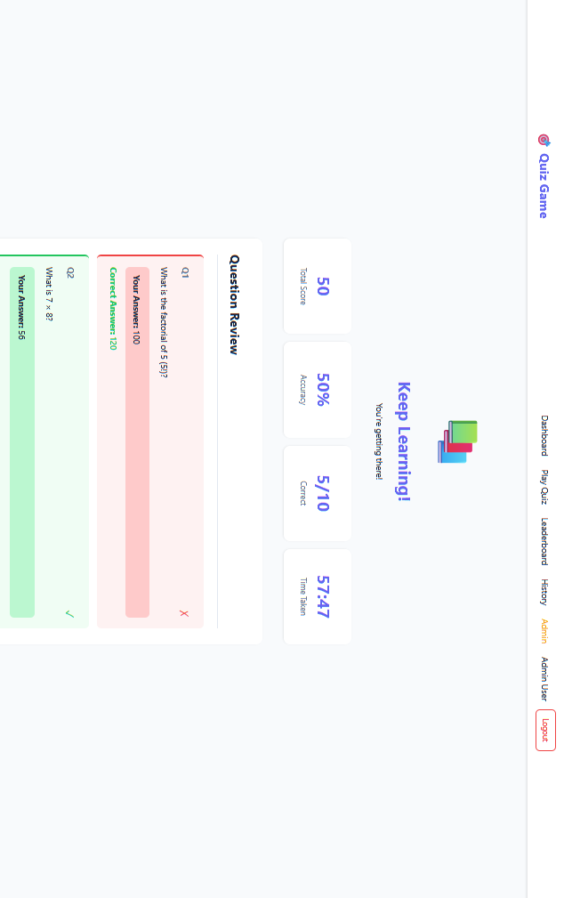

- Here is the result page.
- It can be show the result point wise.
- And it will show the answer true or false.

adminDashboard

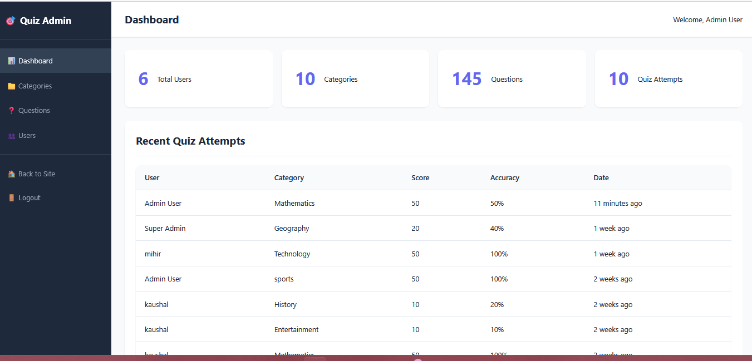

->here is the admindashboard page.
->admin can also show the all details of quiz game.

Admin categories

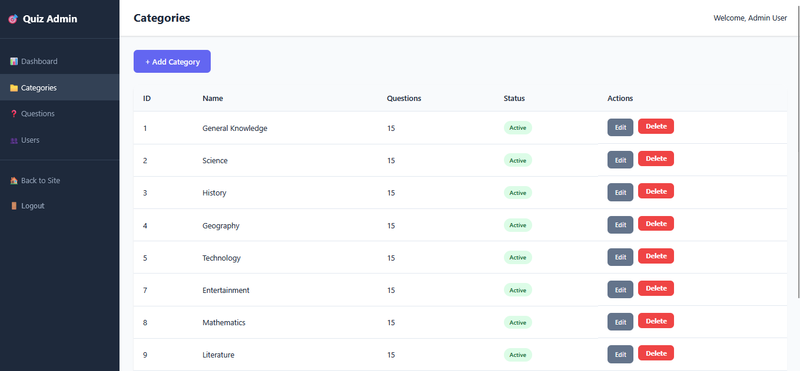

->here is the admin categories page.
->admin can also add new categories ,edit and delete the all categories.

vi

Admin questions

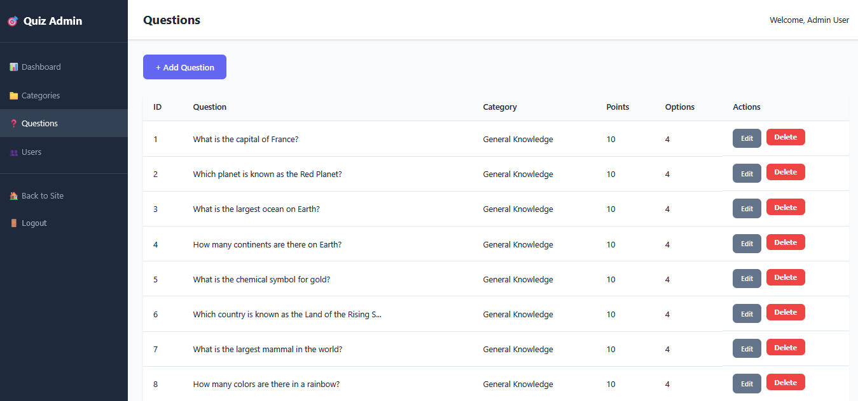

->this is the admin panel question page
-> in this page admin can view update and delete the questions.

User history

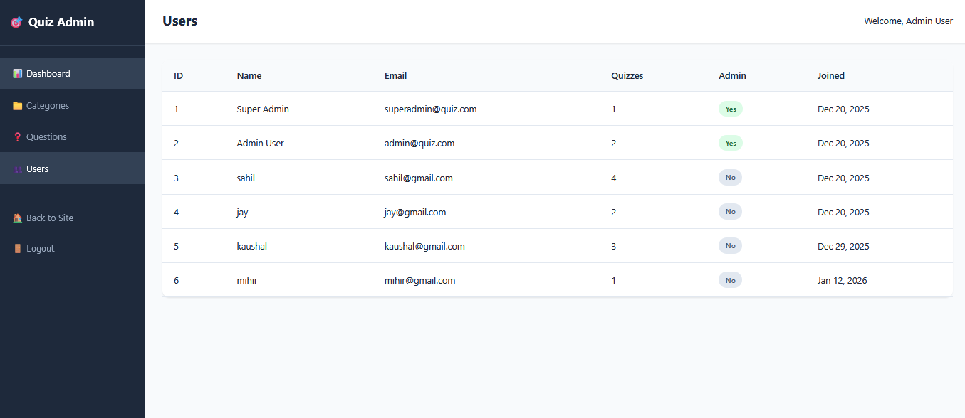

->here is the admin user history.
->admin can show the all user performance.

Test Cases

Test Case | Description | Actual Output | Test Result
Home screen | Display quiz categories, start quiz button, and navigation menu | All quiz categories and navigation options are displayed correctly | Pass
User registration screen | Allow new users to register with valid details | . User registration is completed successfully | Pass
Login screen | Allow registered users to log in using valid credentials | User is logged in and redirected to dashboard | Pass
Quiz category screen | show all available quiz categories | All quiz categories are displayed correctly | Pass
Quiz Question Screen | Display quiz questions with multiple-choice options | Questions and options load correctly | Pass

Limitation
• Limited Scalability
The application is designed for a small to moderate number of users. Performance may degrade when a large number of users attempt to play quizzes simultaneously, as advanced load balancing and caching mechanisms are not implemented.
• Basic Security Features
While standard Laravel authentication is used, the system does not include advanced security measures such as two-factor authentication, encrypted quiz content, or protection against sophisticated cheating techniques.
• Restricted Question Management
Quiz questions are manually added by the administrator. The system does not support automatic question generation, question difficulty balancing, or integration with external question banks.

Future Enhancement
• Real-Time Multiplayer and Leaderboards
Implement real-time multiplayer quizzes and live leaderboards using WebSockets or Laravel Echo to enhance user engagement and competition.
• Advanced Analytics and Reporting
Add detailed performance analytics for users and administrators, including score trends, topic-wise performance, and downloadable reports.
• Enhanced Security and Anti-Cheating Measures
Introduce features such as question randomization, timed sessions, IP-based monitoring, and two-factor authentication to reduce cheating and improve system security.

Webliography

Stack Overflow

W3Schools

TutorialsPoint

Laravel documentation

